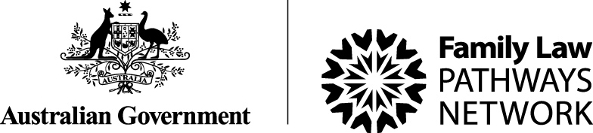
FAR NORTH QUEENSLAND


FNQ Family Law Pathways Network

INVITATION

2021 Breakfast Networking Meeting of Professionals/Practitioners

Cairns Regional Council Reception Room, Spence Street, Cairns
On Wednesday, 16th. February, 7.30 – 9am

The aim of the Family Law Pathways Network is to improve collaboration and co-ordination between organisations operating in the Family Law system to assist separating families obtain appropriate services. FLPN is funded by the Australian Attorney-General’s Department

Limit of 2 professionals/practitioners FREE from each organisation.
Thereafter $25pp for each extra attendee from the same organisation (payable prior to the event)

GETTING TO KNOW PEOPLE FROM LEGAL & NON-LEGAL SERVICES

Come along and meet each other!
Bring your business cards, and if appropriate, information about your organisation

MINGLE OVER BREAKFAST
Please feel free to pass this on to any appropriate person/colleague

RSVP no later than 9th. February using booking form on other side of page

Essential for catering purposes

Any enquiries to Mike Friganiotis, Relationships Australia, ph. 4052 7900 or email: mfriganiotis@raq.org.au

BOOKING FORM

ORGANISATION (print) ………………………………………………………………………………..

PRINT NAME/OCCUPATION (FOR Name Tag)::

1 NAME…… …………………………… OCCUPATION……………………………………………. (FREE)

Phone………………………………….Email…………………………………………………………..

2 NAME…… …………………………… OCCUPATION……………………………………………. (FREE)

Phone………………………………….Email…………………………………………………………..

3 NAME………………………………… OCCUPATION……………………………………………... ($25)

Phone………………………………….Email…………………………………………………………..

4 NAME………………………………… OCCUPATION……………………………………………… ($25)

Phone………………………………….Email…………………………………………………………..

Special food requirements (if any – list first name)…………………………………………………………..

……………………………………………………………………………………………………………………..

NOTE: Payment of $25pp must be made ONLY for 3rd. & subsequent representatives from the same organisation NO LATER THAN 9th. February. Payment may be made by cash (at Relationships Australia, 125 Grafton Street, Cairns), credit card (see below) or cheque (payable to Relationships Australia)

Credit Card (VISA, Mastercard) details – if your payment applies by this method:-

Amount to be paid (ONLY if more than 2 people from the same organisation) TOTAL $................

Name on card……………………………………………….Card Number…………………………………

Expiry Date…………………………………CVN (3 digit number on back of card)…………………..

SIGNED……………………………………………………………….DATE………………………….

I agree that if I cancel after 9th. February, or do not attend on 16th. February, I will be liable for an amount of $25pp to offset catering costs.

Return this form no later than 9th. February to mfriganiotis@raq.org.au

